MEMORANDUM

To: CMAP Climate Committee

From: CMAP Staff

Date: May 15, 2025

Subject: Update on the Comprehensive Climate Action Plan for the Greater Chicago area
Action Requested: Discussion

CMAP staff seeks to update the CMAP Climate Committee on the development of the Comprehensive Climate Action Plan (CAP) for the Greater Chicago area, with funding from U.S. Environmental Protection Agency’s (USEPA) Climate Pollution Reduction Grant program. Since the last update in the fall, staff have developed a process for determining the plan’s reduction targets, identified objectives and strategies to reduce greenhouse gas (GHG) emissions, and created draft scenarios by modeling different paths to reach the plan’s reduction goals. At the May meeting, staff will inform the Climate Committee on the progress to date, share initial economy-wide modeling results for the planning area, and engage in a discussion about the policy and other action needed to help the greater Chicago area drastically reduce GHG emissions by 2050.

Project updates

Greenhouse gas inventory
CMAP staff updated the 2020 Greenhouse Gas Inventory for the 13-county planning area.
The inventory update incorporated revised state-level eGRID electricity emission factors, which affected emissions calculations in key sectors. In 2020, the 13 counties produced approximately 152 million metric tons of carbon dioxide equivalent (MMT CO2e) of GHG emissions (Figure 1 and Figure 2).

Figure 1. Greenhouse gas emissions by county in the greater Chicago area, 2020
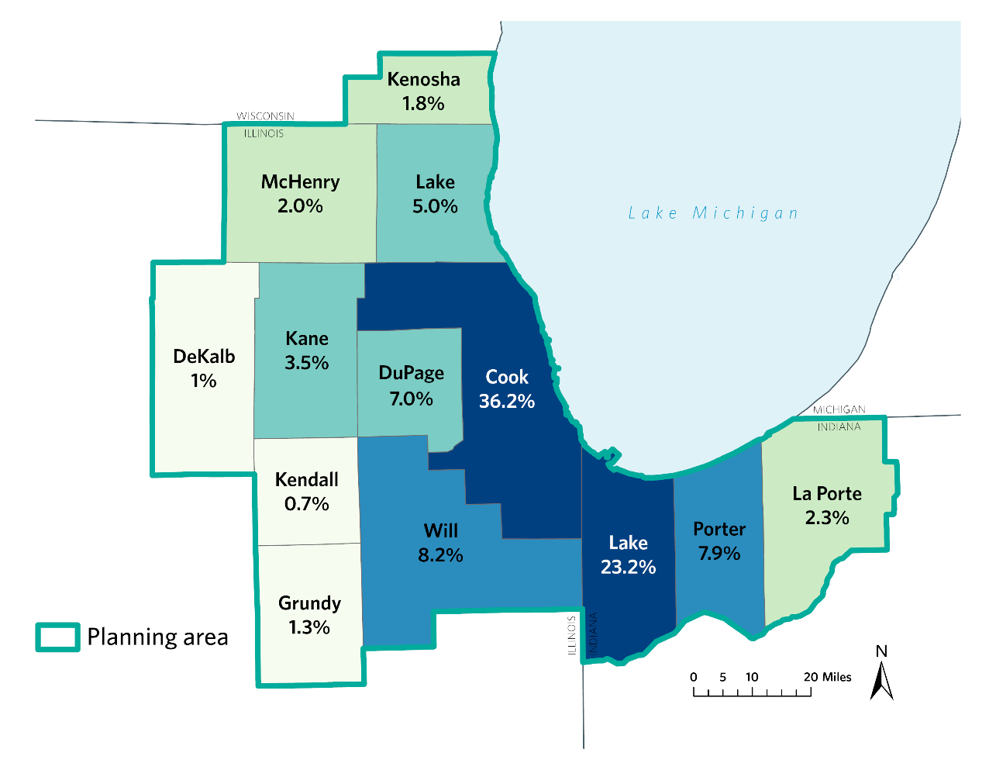
Source: CMAP, 2024.

Figure 2. Greenhouse gas emissions in the greater Chicago area by sector, 2020
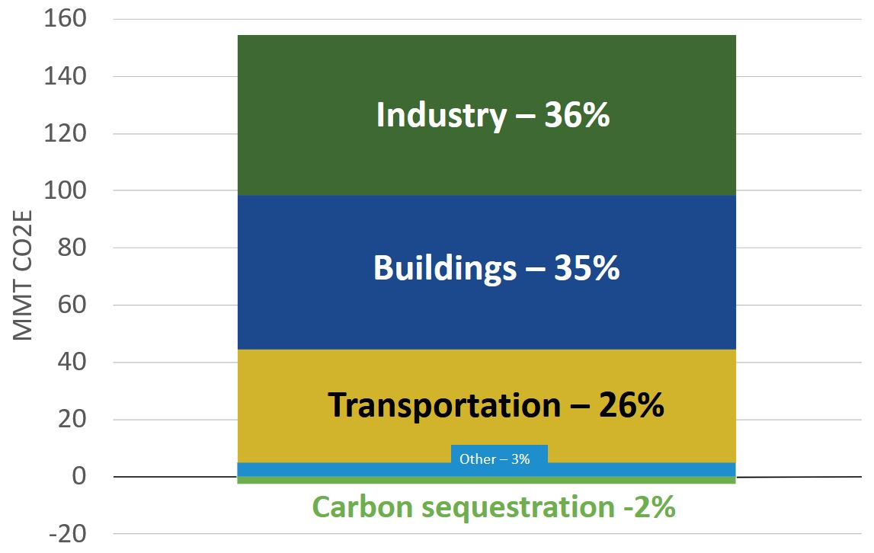
Source: CMAP, 2024.

Greenhouse gas emissions targets
At their October meeting, the CAP steering committee confirmed the recommended approach for setting GHG reduction targets. The CAP planning process will seek to develop an economy-wide target of a gross GHG reduction of 80-85 percent of 2005 emissions by 2050. This means that the plan will demonstrate pathways for reducing all GHG emissions produced within the planning area, excluding negative emissions, by 80-85 percent within the greater Chicago area counties as part of achieving net-zero emissions across the planning area. This approach is recommended for the following reasons:

- This target reflects the reality that a densely populated metro area is unlikely to achieve net-zero emissions within its own boundaries and thus will require assistance from the larger national effort.

- This target is consistent with not only CMAP’s and the City of Chicago’s 2050 target of an 80 percent reduction but also GHG targets for other major cities in states with ambitious climate goals. For example, New York City has an 80 percent reduction target while the state has a net-zero target).

- This target is consistent with emissions modeling used to inform the Biden Administration’s national GHG targets. In those scenarios, gross GHG emissions for the entire U.S. are reduced between 75-85 percent by 2050 with the remaining 15-25 percent of emissions reduced through carbon sequestration in geographically disbursed locations.

- After developing an economy-wide scenario that achieves this target for the greater Chicago area, we will be able to calculate the resulting emissions reductions targets for each sector. The inclusion of sectoral targets is strongly recommended by USEPA and supported by steering committee member input. The project team proposes to calculate these as an output of the economy-wide modeling rather than establishing them as an input. This means that the modeling effort will inform the percent reduction for each sector as well as interim targets (e.g., the reduction we should achieve in the next five years for the buildings sector to be on track).

To meet the grant requirements, the plan must present emissions reductions relative to 2005 levels, requiring the development of a 2005 baseline inventory. CMAP used USEPA’s State Inventory Tool to extract emissions data, for the three states included in this plan, and then applied county level shares from the plan inventory to estimate 2005 emissions for the greater Chicago area.

Between 2005 and 2020, GHG emissions across the 13 counties declined by approximately 20 percent or by nearly 38 MMT CO2e (Figure 3). This means that the plan must demonstrate a pathway to reduce emissions by an additional 123.15 MMT CO2e to meet the 85 percent reduction target.

Figure 3. Greenhouse gas emissions in the greater Chicago area: 2005, 2020, and 2050 target
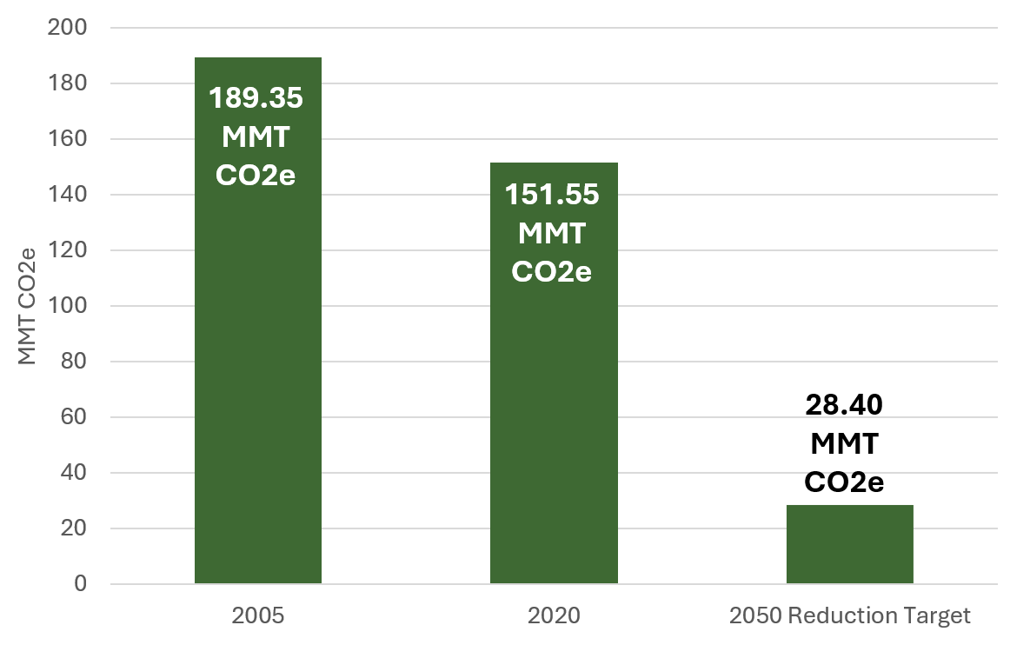
Source: CMAP, 2025.

Emissions modeling
At the May meeting, CMAP staff will share initial economy-wide modeling results for the planning area for discussion and feedback.

Pathways economy-wide model
CMAP is using E3’s Pathways model to create the future GHG emissions scenarios. Pathways is an economy-wide energy and greenhouse gas emissions accounting model. E3 created the Pathways model to help policymakers, businesses, and other stakeholders analyze paths to achieving deep decarbonization of the economy. Pathways is not an optimization or general equilibrium model. Rather, it allows for the comparison of user-defined future energy demand and emissions scenarios to explore the impacts and implications of potential climate and energy policies.

Model variables that impact final energy demand (e.g., customer adoption of electric vehicles, amount of space heating demanded per household) are specified by the user when creating individual scenarios. The Pathways model accounts for annual energy demands and greenhouse gas emissions from final energy demand (e.g., residential, commercial, industrial, and transportation) and non-energy and/or non-combustion sources (e.g., agriculture, natural gas/oil systems, industrial processes/product use, waste, land use and forestry).

The project team will aggregate GHG reduction measures and include them in two scenarios -- the current policy and plan implementation emissions scenarios, as appropriate and as defined below. Modeling results for the two scenarios will illuminate key differences (e.g., state policies, population growth rates, emissions profiles) projected across the planning area, as well as for each state and county.

Future GHG emissions scenarios
Per USEPA requirements, the plan will present projected greenhouse gas reductions through 2050 under two scenarios: a current policy scenario and a plan implementation scenario.

Current policy
The current policy (or business-as-usual) scenario allows us to project out what GHG emissions could be in the future given existing state and federal policies. This scenario helps us understand how far existing policies can advance the region toward meeting its decarbonization goals, while showing how much more we need to reduce through this planning process. The current policy scenario reflects federal policies and assumptions in place at the time of modeling. Given the uncertainty around future federal policy changes, no speculative policy shifts were incorporated into the current policy scenario.

Plan implementation
The plan implementation scenario will show us how the reduction measures identified in the plan will get us to the 80-85 percent reduction target for the planning area. This scenario identifies the relative contributions of state and local actions, enabling the region to better understand their relative effectiveness in achieving the region’s climate goals. By distinguishing what is achievable through local and state leadership versus what will require federal intervention, this scenario helps to identify not only where additional policy action is needed but also the responsible parties.

To inform assumptions around achievable actions for state and local actors, the project team reviewed GHG reduction policies and programs already adopted or implemented in other states and regions. Doing so identified a set of realistic, implementable measures within the control of state and local actors across the greater Chicago area. These measures were then translated into plan implementation model inputs to estimate their potential emissions impact on the region's emissions.

Other project updates

Decarbonization objectives and strategies
CMAP developed a full slate of objectives, strategies, and quantified reduction measures to consider for inclusion in the plan. The project team first developed a list of objectives and corresponding strategies to reduce GHG emissions for each sector. A limited number of reduction measures were then identified based on their potential for quantification (i.e., data availability, model capabilities, and the expected impact of the measures). Many of the strategies were shaped by input from members of the Climate Committee and CAP working groups and informed by recommendations from recent regional decarbonization efforts as well as national and state-level efforts. During the October meeting, Climate Committee members provided feedback on a draft list for agriculture, water and wastewater, waste, and carbon sequestration. In late 2024, the project team vetted the lists for buildings, industry, and transportation with their respective working groups and incorporated feedback into the strategy selection process.

Working groups
Since the last Climate Committee meeting, the project team has held meetings with all four working groups. Below is a summary of findings from each meeting.

Sector working groups
At their second meeting, the sector working groups provided feedback on relevant decarbonization objectives, strategies, and quantified reduction measures.

Buildings working group
- Existing buildings, many of which are older, require energy efficiency and electrification retrofitting to reduce energy consumption and fossil fuel reliance. However, retrofitting has cost, technological, and workforce barriers.
- For new construction, building and zoning codes can require increasingly electrified buildings and promote more efficient development patterns.
- Many federal, state, local, and private sector building decarbonization efforts are underway in the region. It is important to understand both the best practices that can be scaled to a regional level and existing gaps.
- Commercial and residential buildings vary greatly in how they use energy, the technologies needed to decarbonize, their regulating bodies, and the economic pressures they face. Decarbonization strategies and implementation will have to reflect these varying opportunities and challenges between the subsectors

Industry working group
- Among stakeholders, there is consensus around improvements to energy efficiency as a key approach to reducing energy demand and GHG emissions. Stakeholders also support electrification and low-carbon fuels, feedstocks and energy sources.
- Given the high levels of energy needed at many industrial sites, electrification will put a significant strain on existing grid capacity. Collaboration and coordination with electric utilities and grid operators will be critical in facilitating industrial electrification.
- The significant financial costs currently associated with large-scale facility decarbonization are a major barrier; relevant approaches and strategies should take their cost into account.

Transportation working group
- There is broad recognition that electrification is a key strategy to reducing tailpipe emissions. Supplying electric vehicles with clean energy sources will reduce upstream emissions.
- Transit expansion and active transportation improvements can both reduce emissions and decrease the number of single-occupancy vehicles on roadways. Those improvements could be financed by reinvesting revenues from congestion pricing and/or other roadway fees.
- Focusing on interconnected sectors and disciplines will be critical, especially freight transportation, energy generation, roadway design, and land use planning.

Equity working group
The equity working group held its second meeting in October, focused on methods for engaging communities and incorporating community feedback into the plan. Specifically, the meeting solicited feedback to inform a forthcoming public questionnaire.
- Members shared experiences around how their input has been incorporated in the past. Common concerns generally included a lack of follow-up after the provision of public comment, insufficient time to meaningfully incorporate feedback into planning or decision-making, and a need for more transparency.
- Members offered suggestions for promoting the public questionnaire, including through places of worship, scheduled community meetings, and door-to-door flyers.
- Members provided feedback on the survey questions including the need for simple language, explanations of less familiar strategies (e.g., nature-based solutions), and options tailored to better reflect community priorities and concerns.

Pandemic-related changes in transportation and energy consumption make 2020 an anomalous year for some datasets, but it is still a viable year for this analysis. The inventory is built using modeled and reported data from various time scales and geographies, which reduces the impacts of short-term fluctuations, such as those experienced in 2020. The inventory results are comparable to past efforts to study emissions in the region.
In November 2024, the 2020 Greenhouse Gas Inventory was updated to incorporate state-specific eGRID emission factors for quantifying the GHG impacts of electricity consumption. These updated factors significantly impacted emissions in the residential, commercial, and industrial building subsectors. Illinois counties experienced a decrease in emissions due to a lower emissions factor, while Indiana and Wisconsin saw increased emissions due to a more carbon-intensive emissions factor.
City of New York, “New York City’s Roadmap to 80 x 50,” September 2016, https://www.nyc.gov/assets/sustainability/downloads/pdf/publications/New%20York%20City%27s%20Roadmap%20to%2080%20x%2050_Final.pdf.
New York State, “Scoping Plan,” December 2022, https://climate.ny.gov/resources/scoping-plan/.
Russell Horowitz et al., “The energy system transformation needed to achieve the US long-term strategy,” July 20, 2022, https://www.sciencedirect.com/science/article/pii/S2542435122002513.

